
Дисциплина: Технология и инструментальные средства разработки ПО
Отчет по практической работе №1.2: «Создание схемы БД на SQL».

Выполнил:
Группа: 3-ИСП9-54
Студент: Мкртчян Юрик

Проверил преподаватель:
Кондыбаева А.Б.

Москва 2026 г.

1. Листинги скриптов
PRAGMA foreign_keys = ON;

CREATE TABLE Roles (
id INTEGER PRIMARY KEY AUTOINCREMENT,
name TEXT NOT NULL UNIQUE
CHECK (name IN ('Клиент', 'Менеджер', 'Администратор'))
);

CREATE TABLE Users (
id INTEGER PRIMARY KEY AUTOINCREMENT,
full_name TEXT NOT NULL,
login TEXT NOT NULL UNIQUE,
role_id INTEGER NOT NULL,
FOREIGN KEY (role_id) REFERENCES Roles(id) ON DELETE RESTRICT
);

CREATE TABLE Categories (
id INTEGER PRIMARY KEY AUTOINCREMENT,
name TEXT NOT NULL UNIQUE
);

CREATE TABLE Manufacturers (
id INTEGER PRIMARY KEY AUTOINCREMENT,
name TEXT NOT NULL UNIQUE
);

CREATE TABLE Sizes (
id INTEGER PRIMARY KEY AUTOINCREMENT,
value REAL NOT NULL UNIQUE CHECK (value BETWEEN 15 AND 50)
);

CREATE TABLE Products (
id INTEGER PRIMARY KEY AUTOINCREMENT,
name TEXT NOT NULL,
category_id INTEGER NOT NULL,
manufacturer_id INTEGER NOT NULL,
description TEXT,
price REAL NOT NULL CHECK (price > 0),
image TEXT,
UNIQUE (name, manufacturer_id),
FOREIGN KEY (category_id) REFERENCES Categories(id) ON DELETE RESTRICT,
FOREIGN KEY (manufacturer_id) REFERENCES Manufacturers(id) ON DELETE RESTRICT
);

CREATE TABLE Stock (
id INTEGER PRIMARY KEY AUTOINCREMENT,
product_id INTEGER NOT NULL,
size_id INTEGER NOT NULL,
quantity INTEGER NOT NULL DEFAULT 0 CHECK (quantity >= 0),
UNIQUE (product_id, size_id),
FOREIGN KEY (product_id) REFERENCES Products(id) ON DELETE CASCADE,
FOREIGN KEY (size_id) REFERENCES Sizes(id) ON DELETE RESTRICT
);

CREATE TABLE Orders (
id INTEGER PRIMARY KEY AUTOINCREMENT,
order_num TEXT NOT NULL UNIQUE,
order_date TEXT NOT NULL CHECK (date(order_date) IS NOT NULL),
user_id INTEGER NOT NULL,
FOREIGN KEY (user_id) REFERENCES Users(id) ON DELETE RESTRICT
);

CREATE TABLE OrderItems (
id INTEGER PRIMARY KEY AUTOINCREMENT,
order_id INTEGER NOT NULL,
product_id INTEGER NOT NULL,
size_id INTEGER NOT NULL,
quantity INTEGER NOT NULL CHECK (quantity > 0),
unit_price REAL NOT NULL CHECK (unit_price >= 0),
FOREIGN KEY (order_id) REFERENCES Orders(id) ON DELETE CASCADE,
FOREIGN KEY (product_id) REFERENCES Products(id) ON DELETE RESTRICT,
FOREIGN KEY (size_id) REFERENCES Sizes(id) ON DELETE RESTRICT
);

CREATE INDEX idx_products_category ON Products(category_id);
CREATE INDEX idx_products_manufacturer ON Products(manufacturer_id);
CREATE INDEX idx_products_name ON Products(name);
CREATE INDEX idx_stock_product ON Stock(product_id);
CREATE INDEX idx_orders_date ON Orders(order_date);
CREATE INDEX idx_orders_user ON Orders(user_id);
CREATE INDEX idx_orderitems_order ON OrderItems(order_id);
CREATE INDEX idx_orderitems_product ON OrderItems(product_id);

2. Скриншоты с результатами запуска:
Рисунок 1 – создание бд и список таблиц 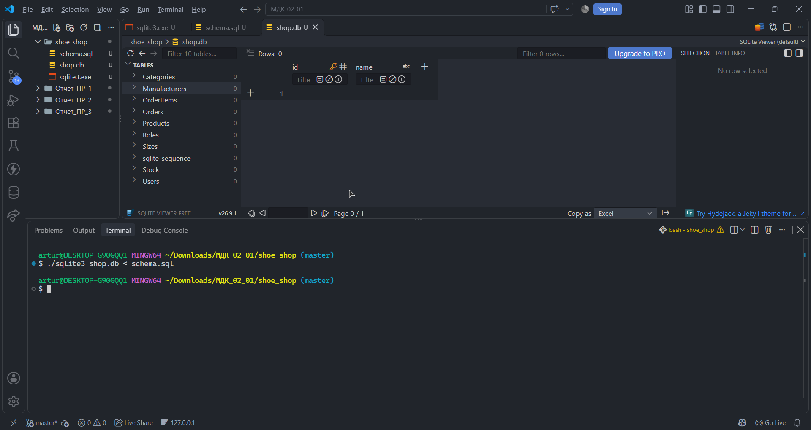
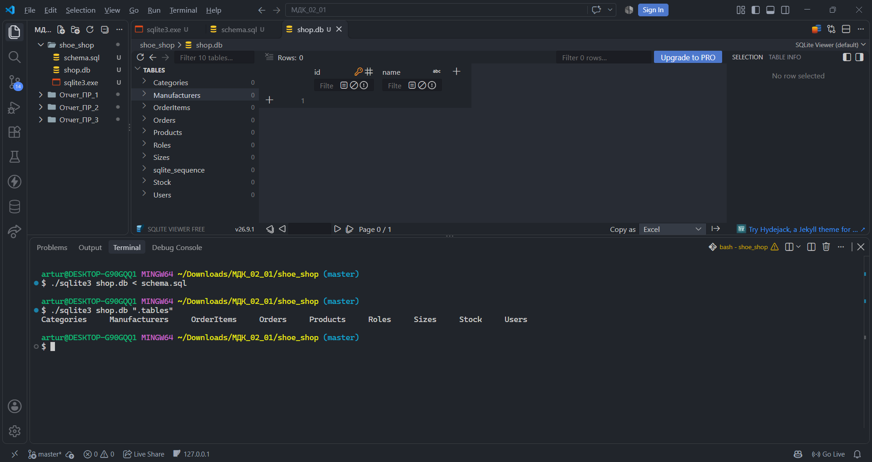
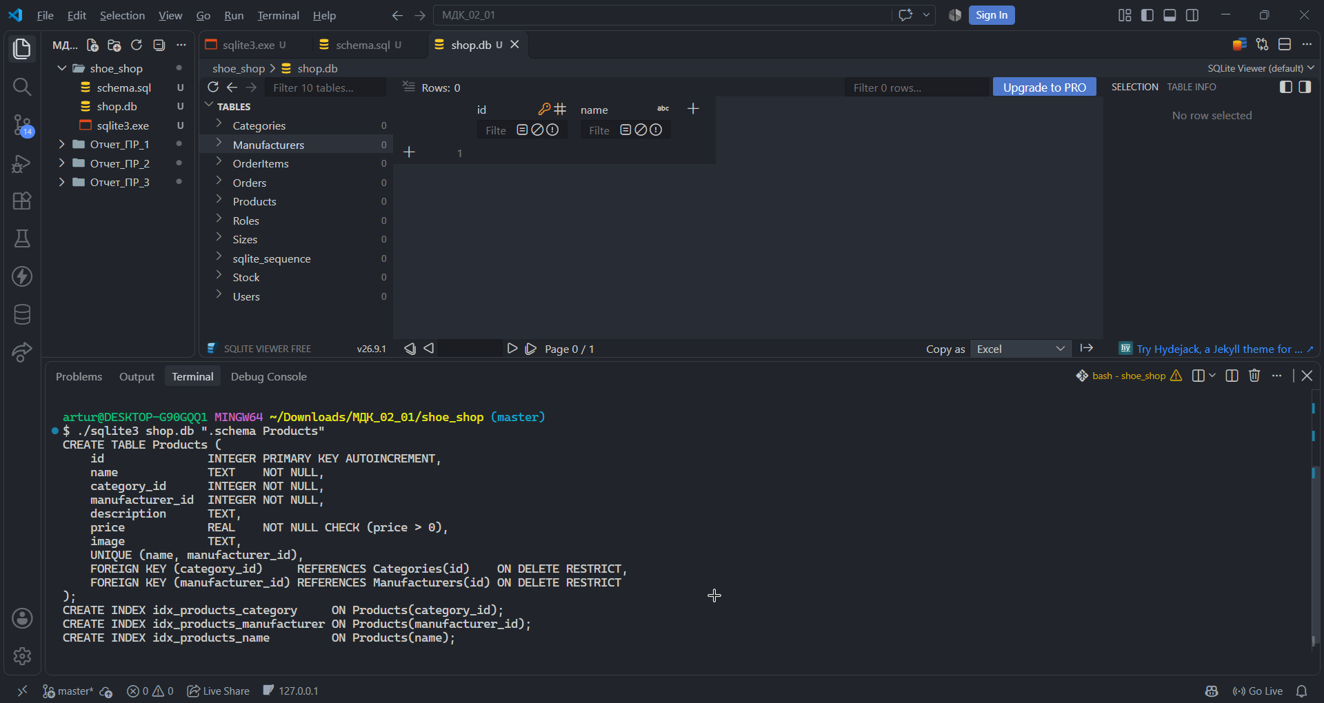
Рисунок 2 – срабатывание ограничения check при вставке размера 100